Lab 3: MapReduce Programming

Experiments

Basics
- Go through the Apache Hadoop introduction to get the general idea about Hadoop:
http://hadoop.apache.org/
- Go through the Apache Hadoop release notes to understand the evolution of Hadoop:
http://hadoop.apache.org/releases.html

Hadoop Single Node Mode.
- Follow the instructions on
http://hadoop.apache.org/docs/stable/hadoop-project-dist/hadoop-common/SingleCluster.html to set up Hadoop environment on your own Linux machine or use QuickStart VM from Cloudera http://www.cloudera.com/content/cloudera/en/documentation/core/v5-2- x/topics/cloudera_quickstart_vm.html
- Follow the instructions/tutorials from the above links to run simple word count program using MapReduce.

Hadoop “cluster”
Your TA will provide you with login information for connecting to a small cloud. Connect to the cloud, create VMs and run a simple Word Count program in Hadoop.

- SSH to the CloudStack.
- Two VMs are already created for each group, one is the master node and the other one is the slave node. Please use the corresponding IP addresses to SSH the two VMs your groups is assigned.
- Configure Master and Slave nodes to create a small Hadoop cluster.
- Run the WordCount Hadoop job on the file the TA provides to you.

Reports
- What are the differences between Hadoop 0.X, 1.X, 2.X?

Features by version:

Hadoop 0:
C++ API for MapReduce
Eclipse Plugin, including HDFS browsing, job monitoring, etc.
File modification times in HDFS
HBase support with hflush and hync
rpms and debs released
DistibutedCache Sharing
Dynamically stop/start job queues

Hadoop 1:
Limited up to 4000 nodes per cluster
Only has one namespace for managing HDFS
Webhdfs released
Map and Reduce slots are static
Only job to run is MapReduce

Hadoop 2:
Potentially up to 10,000 nodes per cluster
Supports multiple namespace for managing HDFS
Efficient cluster utilization (YARN)
MRv1 backward and forward compatible
Any apps can integrate with Hadoop
YARN released

Hadoop 1.X versions called HDFS, have a single Namenode managed the entire namespace for a Hadoop cluster. With HDFS federation, multiple Namenode servers manage namespaces and this allows for horizontal scaling, performance improvements, and multiple namespaces.
Hadoop 2.X versions is called YARN, brings significant performance improvements for some applications, supports additional processing models, and implements a more flexible execution engine.

- What is YARN? Why do we need YARN?

YARN is the new version of MapReduce. With the introduction of YARN, the primary responsibilities of the JobTracker- Resource Management and Job Scheduling/monitoring, have been split into two separate daemons: a global ResourceManager and per-application ApplicationMasters. With MRv2, the ResourceManager (RM) and per-node NodeManagers (NM), form the data-computation framework. The ResourceManager service effectively replaces the functions of the JobTracker, and NodeManagers run on slave nodes instead of TaskTracker daemons. The per-application ApplicationMaster is, in effect, a framework specific library and is tasked with negotiating resources from the ResourceManager and working with the NodeManager to execute and monitor the tasks. As a result due to YARN now multiple processes can be managed and executed at the same time.

- What is Hadoop streaming?

Hadoop streaming is a utility that comes with the Hadoop distribution. The utility allows us to create and run Map/Reduce jobs with any executable or script (eg Java, stdin, stdout etc) as the mapper and/or the reducer.

It is a utility that comes with Hadoop distribution. The utility will create a Map/Reduce job, submit the job to an appropriate cluster, and monitor the progress of the job until it completes. When an executable is specified for mappers, each mapper task will launch the executable as a separate process when the mapper is initialized. As the mapper task runs, it converts its inputs into lines and feeds the lines to the stdin (input) of the process. In the meantime, the mapper collects the line oriented outputs from the stdout (output) of the process and converts each line into a key/value pair, which is collected as the output of the mapper. By default, a line up to the first tab character is the key and the rest of the line (excluding the tab character) will be the value. If there is no tab character in the line, then entire line is considered as key and the value is null.

- Screenshots of the practice (word count) of single node Hadoop on your own computer. The screenshot should show the output and result of Hadoop execution as well as the files in HDFS.

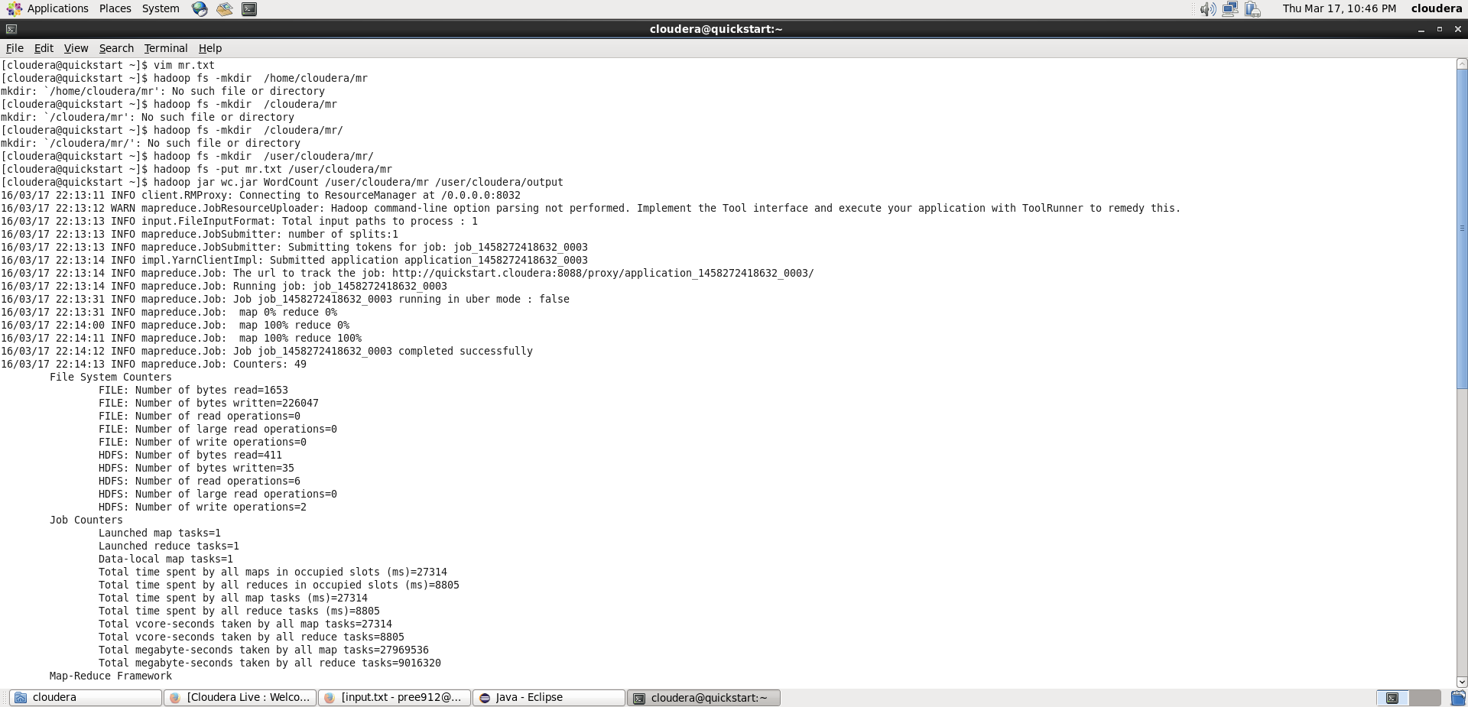

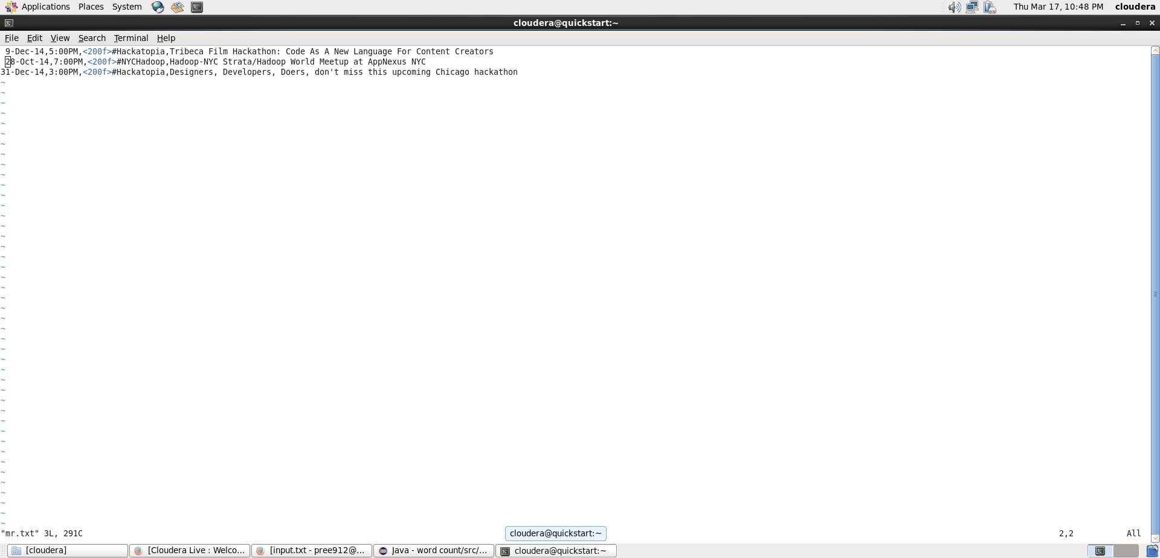

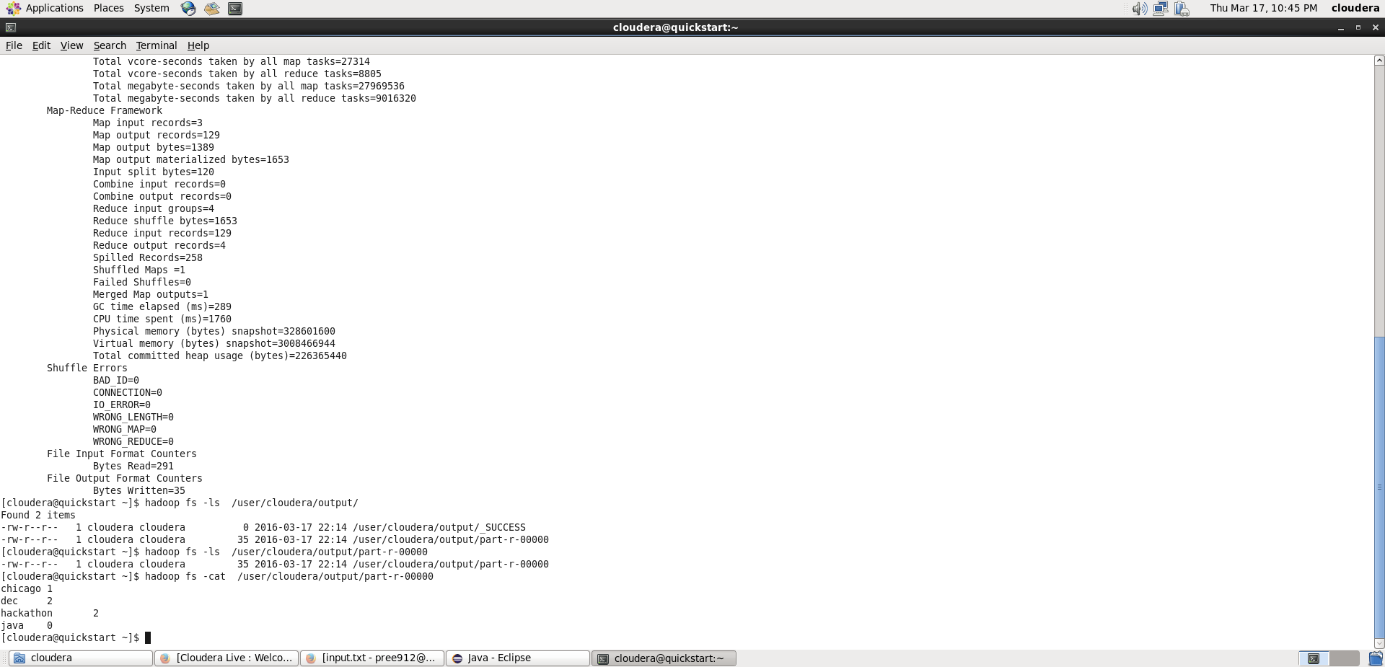

- What are the top 5 most frequent word in the provided txt file?

Project 5

Plain 2

Come, Defects, Information, I , J ,Right, Viator 1

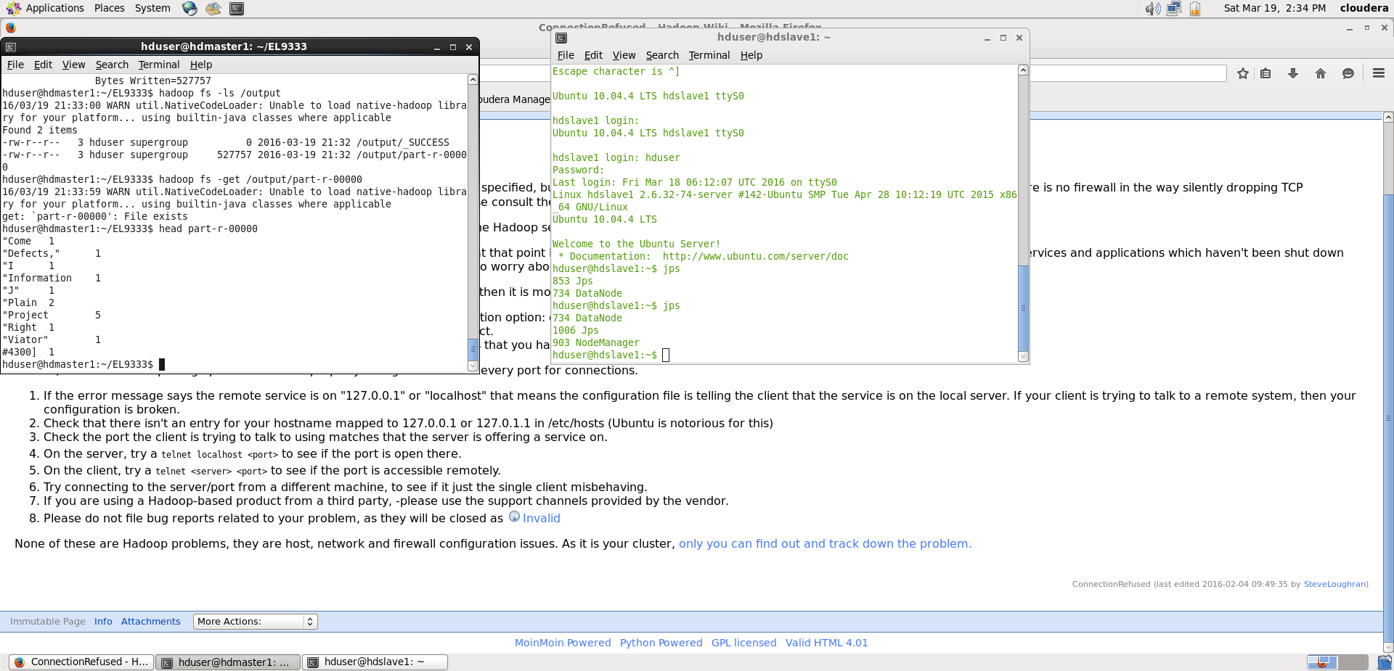

- Use jps commands on both VMs to show running Hadoop daemons and provide and screenshots.

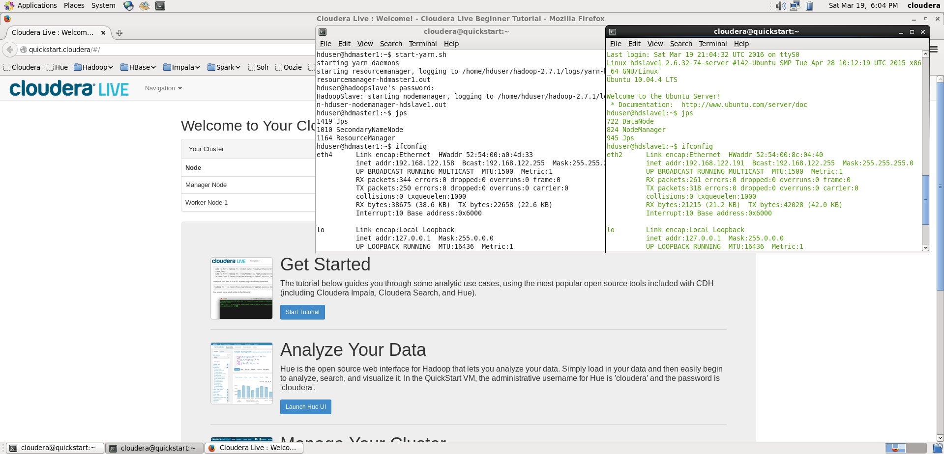

- Screenshots of configuration files and IP addresses for Master node and Slave node on the small cloud as well as the MapReduce execution result. For each configuration file, please also briefly explain what it does.
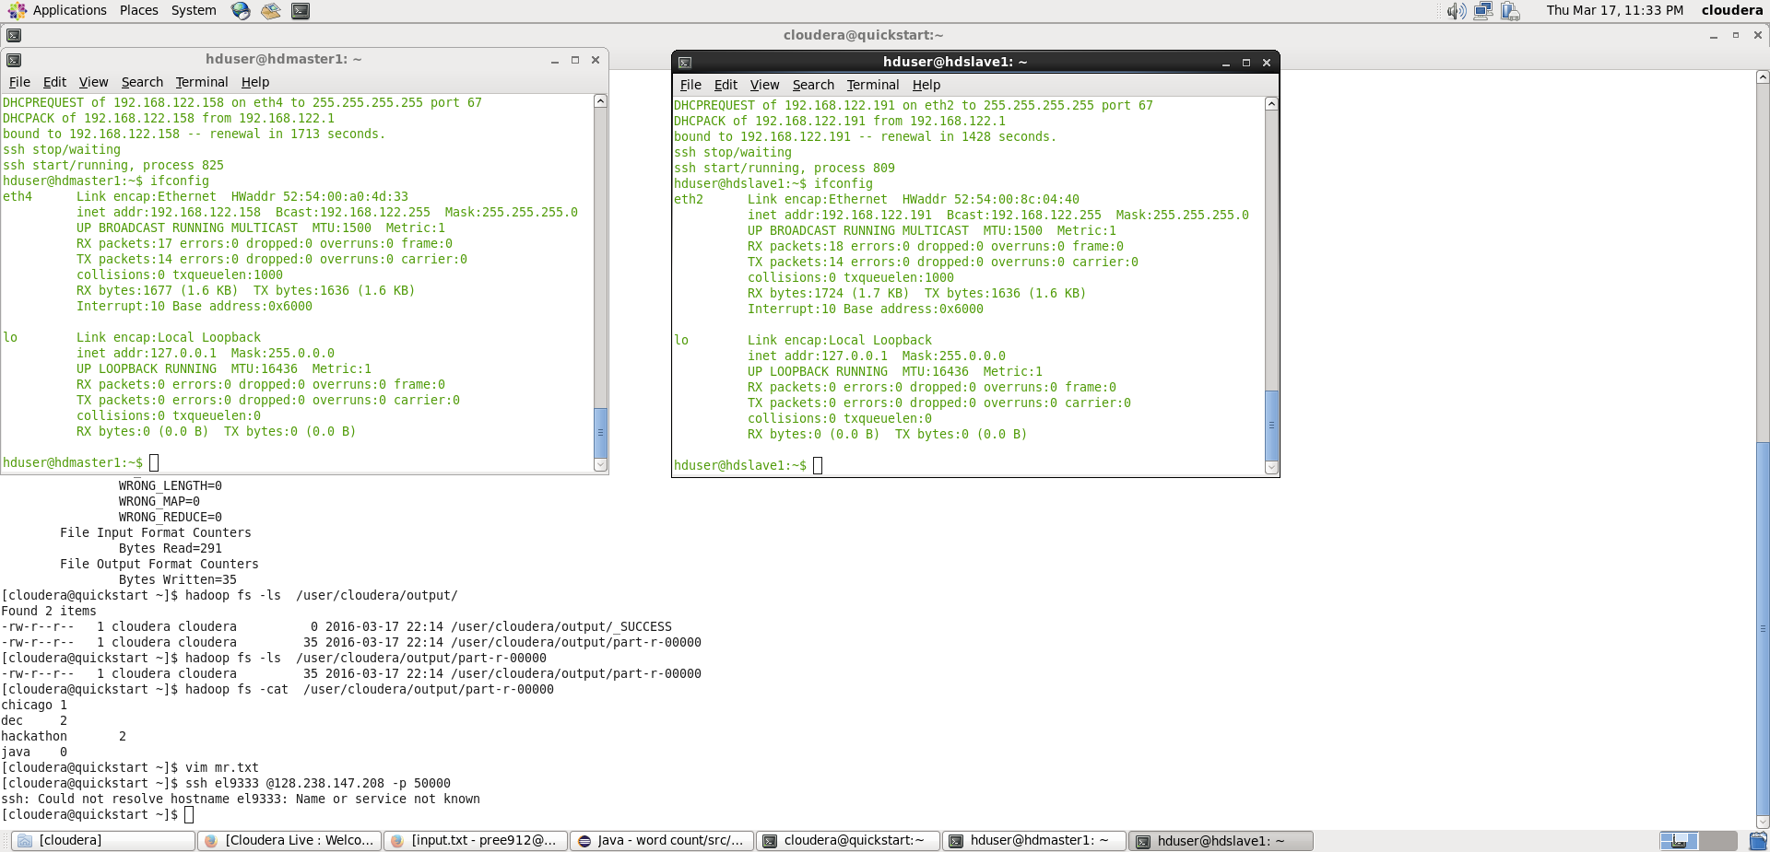

Map reduce execution result:

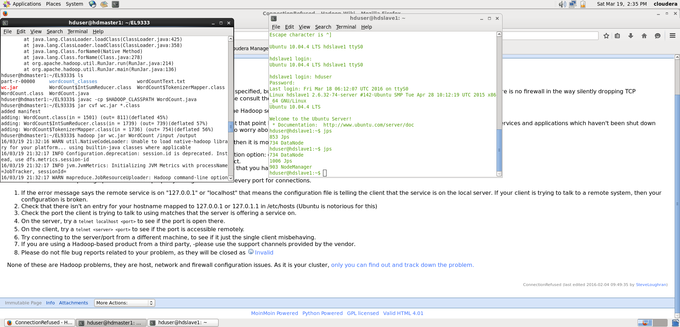
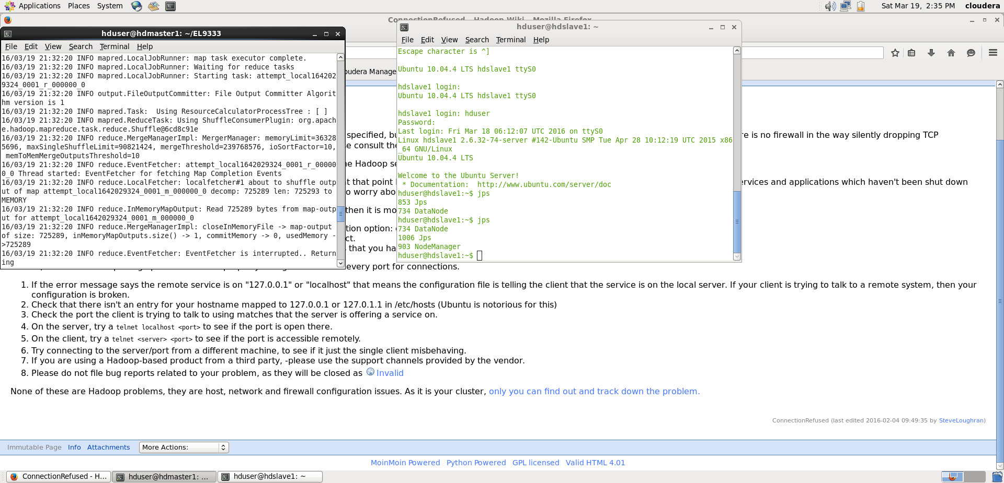
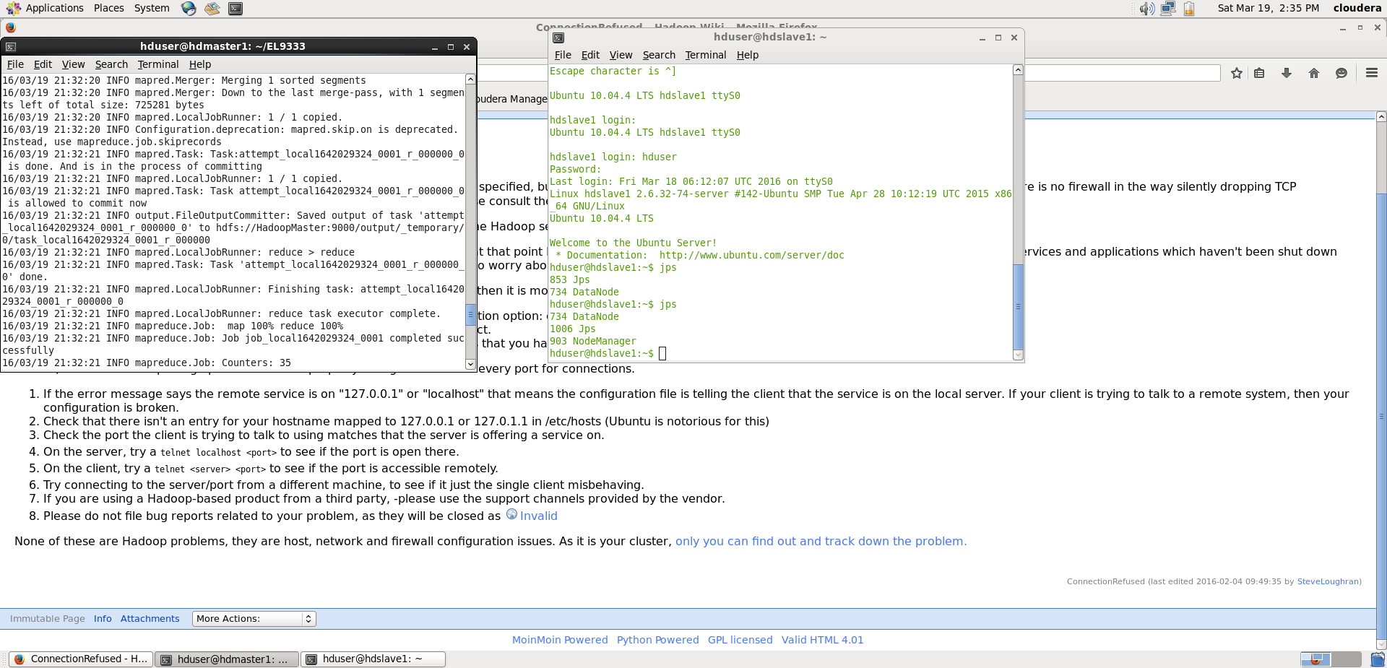
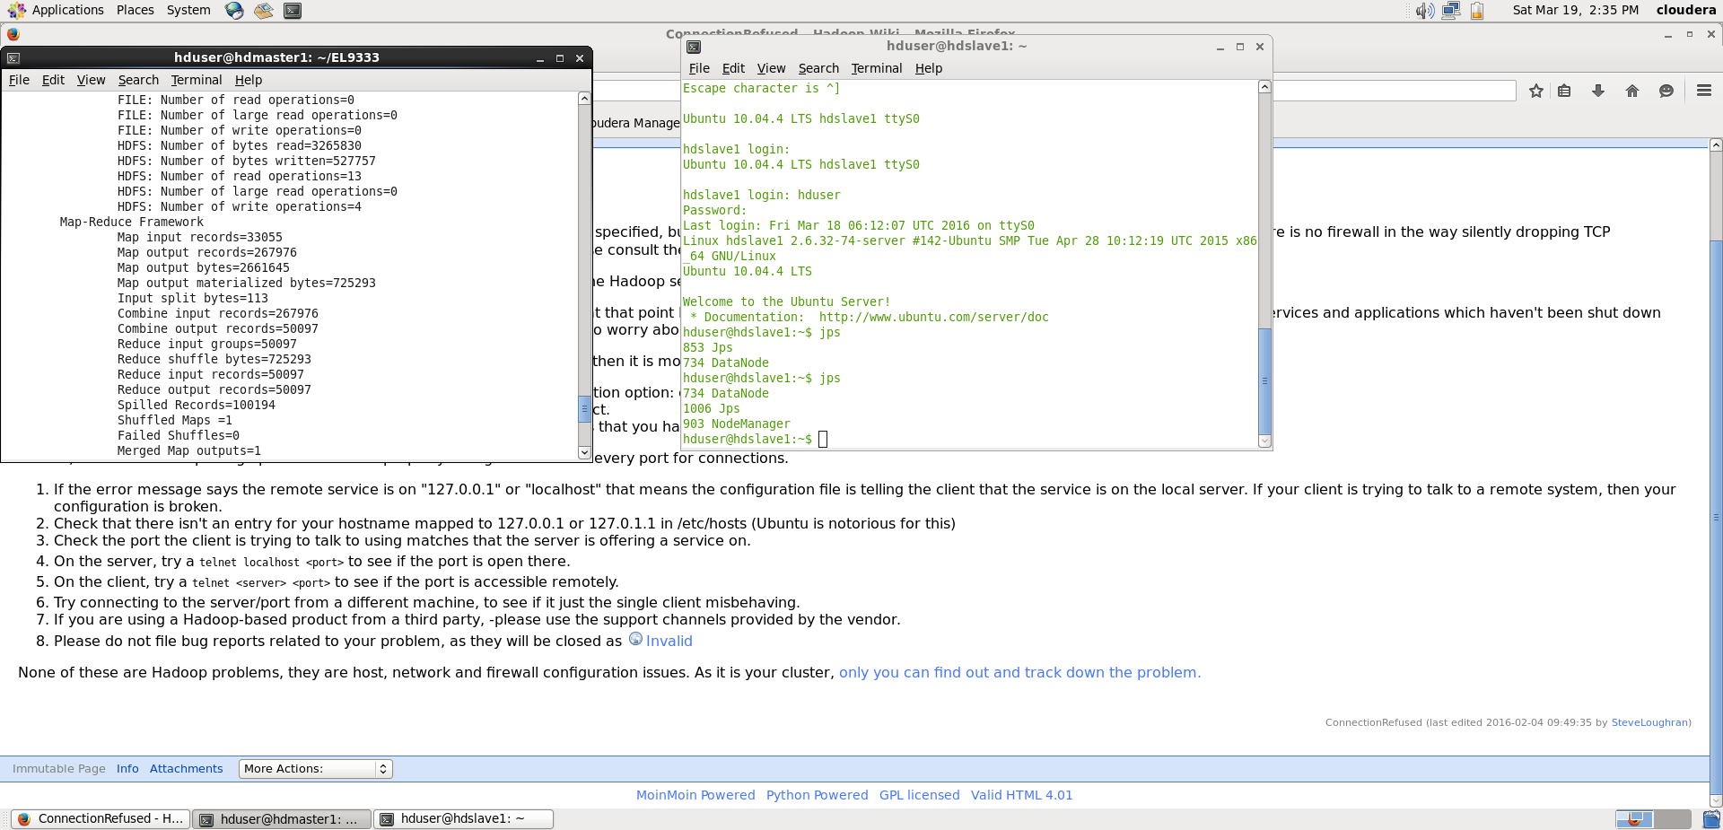
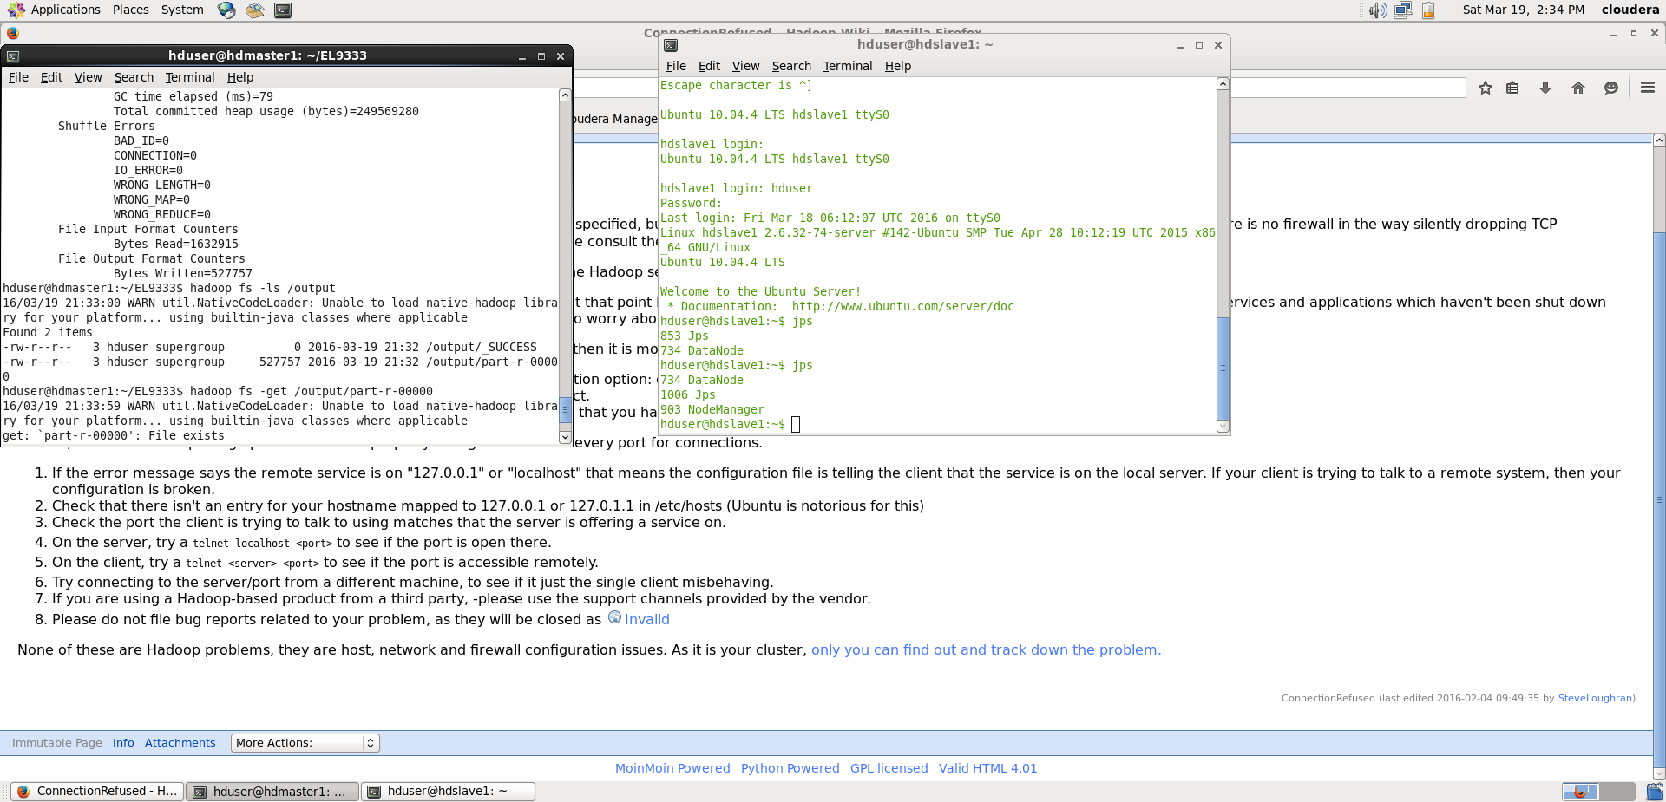

Configuration files:

- /etc/hosts

- hadoop-2.7.1/etc/hadoop/core-site.xml
This file contains configuration settings for Hadoop core. It shows the name and port number of the machine on which daemon name node runs.
- hadoop-2.7.1/etc/hadoop/hdfs-site.xml
This file contains configuration settings for HDFS daemons, namenode, secondary namenode and the data nodes. The user can configure the file to specify default block of replication and permission checking on HDFS.
- hadoop-2.7.1/etc/hadoop/yarn-site.xml
This file contains configuration settings that override the default values of YARN parameters
- hadoop-2.7.1/etc/hadoop/mapred-site.xml.template
This file contains configuration settings for MapReduce daemons, the job-tracker and the task-trackers. The mapred.job.tracker parameter is a hostname or could be IP address and port pair on which the job tracker listens for RPC communication.
- hadoop-2.7.1/etc/hadoop/masters
This file informs about the Secondary Namenode location to Hadoop daemon.
- hadoop-2.7.1/etc/hadoop/slaves
This file contains a list of hosts that are to host Data Node and Task Tracker servers.
- What are the differences between Hadoop master and slave nodes? Also name which functionalities are performed on each node.

The master nodes in distributed Hadoop clusters host the various storage and processing management services whereas slave nodes are where Hadoop data is stored and where data processing takes place.

HDFS NameNode, Secondary NameNode, MapReduce JobTracker, and the HBase Master are examples of Master nodes and HDFS DataNodes, MapReduce TaskTrackers, and HBase RegionServers are examples of slave nodes.

- Write a pseudo code to multiply large matrices using Hadoop. Also explain the function of your Mappers
and Reducers.

map(key, value):
// value is ("A", i, j, a_ij) or ("B", j, k, b_jk)
if value[0] == "A":
i = value[1]
j = value[2]
a_ij = value[3]
emit(j, ("A", i, a_ij))
else:
j = value[1]
k = value[2]
b_jk = value[3]
emit(j, ("B", k, b_jk))

reduce(key, values):
// key is j
// values is a list of ("A", i, a_ij) and ("B", k, b_jk)
list_A = [(i, a_ij) for (M, i, a_ij) in values if M == "A"]
list_B = [(k, b_jk) for (M, k, b_jk) in values if M == "B"]
for (i, a_ij) in list_A:
for (k, b_jk) in list_B:
emit((i, k), a_ij*b_jk)
result += hash_A[j] * hash_B[j]
emit(key, result)

So using the mapper function, each of the elements of matrices A and B are mapped. So in the map phase all the elements of each row of A and each row of B are mapped to the corresponding element. So for example the element (1,1) of the result will require all elements of row 1 of matrix A and column 1 of Matrix B. So, all these elements are emitted for that corresponding element in the map phase.
In the reduce phase, we just take the dot product of the corresponding elements of A & B. So (1,1) we will take the dot product of elements of row 1 of matrix A and row 1 of matrix B. So, we’ll multiply all the elements and take their sum.

So, this is how matrix multiplication works in map reduce.

- What is a combiner? Add a combiner to the last question and explain its function.

The combiner function is used as an optimization for the MapReduce job. The combiner function runs on the output of the map phase and is used as a filtering or an aggregating step to lessen the number of intermediate keys that are being passed to the reducer. In most of the cases the reducer class is set to be the combiner class. The difference lies in the output from these classes. The output of the combiner class is the intermediate data that is passed to the reducer whereas the output of the reducer is passed to the output file on disk.

So, in the above example there is a reduce function for each element. So, if the reduce node doesn’t have enough memory then we won’t get the correct result. So, we used the combiner function and used two reduce functions, one for the product and the other for the sum. So, once we got the product from the first reduce process, we used its result to compute the sum using the second reduce process with the combiner function.

map(key, value):
// value is ("A", i, j, a_ij) or ("B", j, k, b_jk)
if value[0] == "A":
i = value[1]
j = value[2]
a_ij = value[3]
emit(j, ("A", i, a_ij))
else:
j = value[1]
k = value[2]
b_jk = value[3]
emit(j, ("B", k, b_jk))

reduce(key, values):
// key is j
// values is a list of ("A", i, a_ij) and ("B", k, b_jk)
list_A = [(i, a_ij) for (M, i, a_ij) in values if M == "A"]
list_B = [(k, b_jk) for (M, k, b_jk) in values if M == "B"]
for (i, a_ij) in list_A:
for (k, b_jk) in list_B:
emit((i, k), a_ij*b_jk)

map(key, value):
emit(key, value)

reduce(key, values):
result = 0
for value in values:
result += value
emit(key, result)

We have zero tolerance to forged or fabricated data!! A single piece of forged/fabricated data would bring the total score down to zero.

